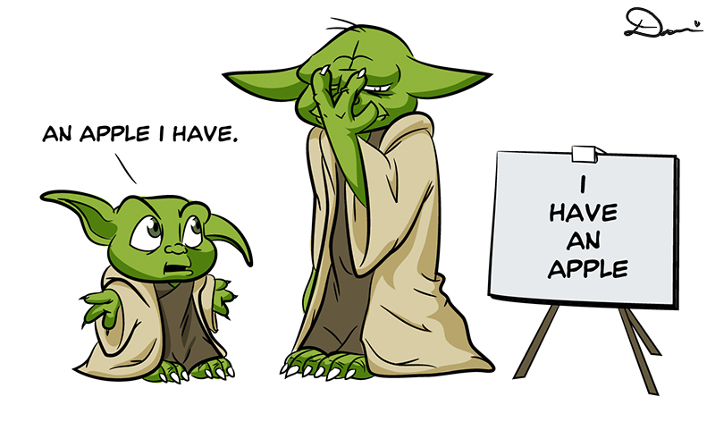

**Word order**

Woordvolgorde

* In het Engels staan woordsoorten bijna altijd op dezelfde volgorde (bij normale zinnen).
* Als er zowel Plaats én Tijd in een zin staan dan staan ze altijd in deze volgorde.
* Tijd mag ook helemaal vooraan in de zin, plaats blijft op het einde staan.
* Het bijwoord en bijvoeglijk naamwoord kunnen wel op verschillende plaatsen staan.

|  |  |  |  |  |  |  |
| --- | --- | --- | --- | --- | --- | --- |
| **1**  **Onderwerp** | **2**  **Bijwoord** | **3**  **Werk-woorden** | **4**  **Mee-werkend voorwerp** | **5**  **Lijdend voorwerp** | **6**  **Plaats** | **7**  **Tijd** |
| Wie/ wat doet iets? | Hoe iets gebeurd | Alle actie-woorden in de zin | Aan/ voor wie wordt iets gedaan | Met wie of wat wordt iets gedaan | Waar het gebeurd | Wanneer het gebeurd |
| *They* | *happily* | *gave* | *her* | *flowers* | *at school* | *yesterday.* |
| *I* |  | *wish* | *you* | *the best.* |  |  |

1. **Put slashes *(schuine strepen)*  between the parts of the sentence. Put the correct numbers underneath.**
2. They take selfies at school.
3. Cody Gakpo plays football at the Herdgang.
4. The students are listening at the moment.
5. **Put the parts between slashes in the correct order.**
6. the / on the beach / pretty / sit / girls
7. often / in the cinema / Gremlins / sing
8. meet / school / after / Max Verstappen
9. darts / playing / the boys / are
10. sister / and / has / brothers / he / two / one
11. **LEVEL 3 + LEVEL 4 STUDENTS**

**Put the parts between slashes in the correct order.**

1. he / while / himself / the car / hurt / Sandy / was repairing
2. are / work / they / to / on their own / expected.
3. whose / author / the book / I / on the / met / is / best-seller list
4. to change / their / like / many women / from time to time / appearance
5. to work / football / go / game / Joe / to the / he / has / because / can't.
6. **Write an email to your teacher (e.kuindersma@yuverta.nl). You may choose three from any of the subjects below. Mind your word order! The amount of words:**

**Level 2 = 30 words Level 3 = 50 words Level 4 = 70 words**

1. Write about a place that you visited once.
2. How did you bring joy or happiness to someone other than your family this month?
3. Who is the person you spent the most time with and why? What did you do with them?
4. What was one new thing you did this year that you didn't do last year?
5. Think of a New Year's resolution you made, did you keep it, and explain why you did or didn’t.
6. How will you change your life next year? Describe the steps you are going to take.
7. Write about something you are looking forward to doing this year and why.